Download patches from below

<https://docs.vmware.com/en/VMware-vSphere/6.7/rn/vsphere-vcenter-server-67u2-release-notes.html#full_patch>

Once you download patch, upload this patch to VSAN storage with winscp (connect esxi host, vmfs,volumes, <vsan name> create folder and copy here.

Take snapshots for PSC and vcenter

Mount cd/dvd to vcenter server from vm edit settings.

If you run extended PSC first mount on extended PSC and finish that first

login vami :5480 with root

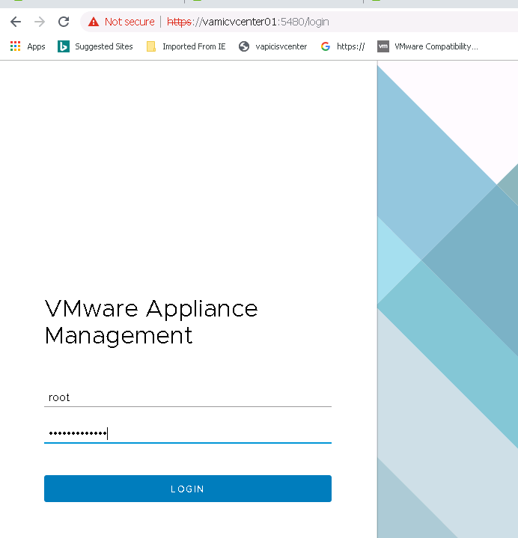

Take screenshot current version

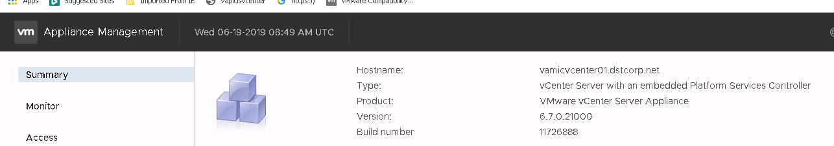

Check for updates

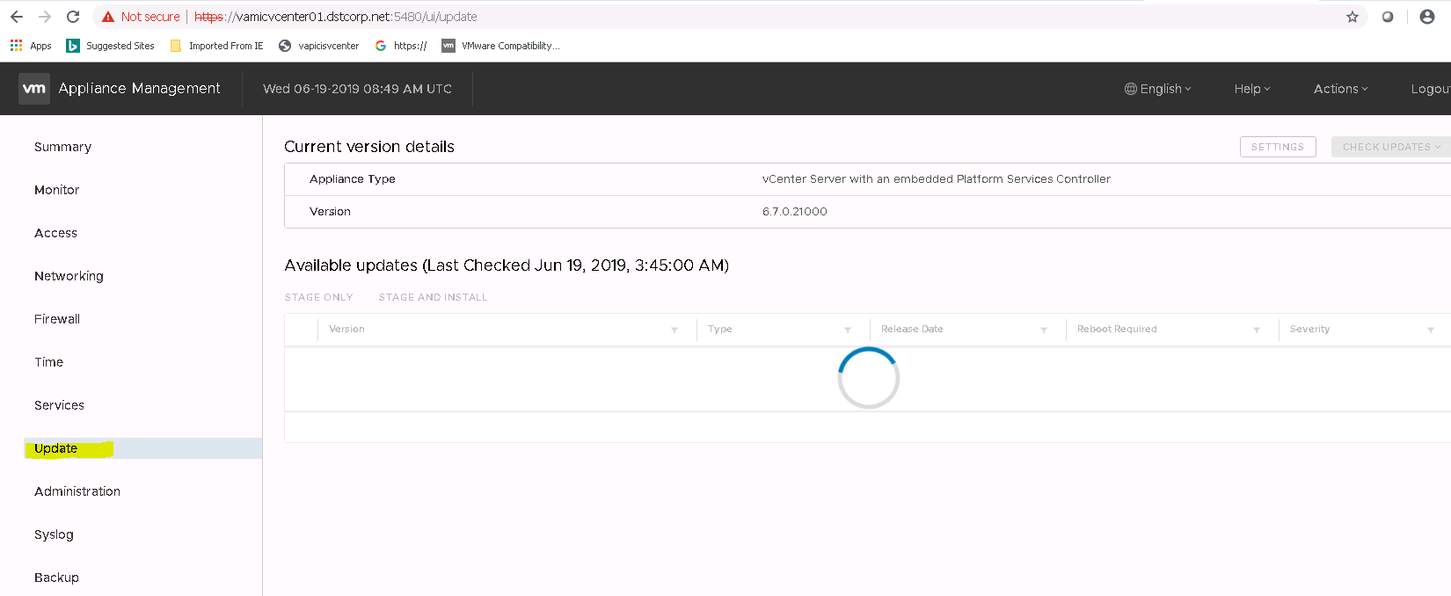

Check updates from CD ROM, it shows mounted ISO patch

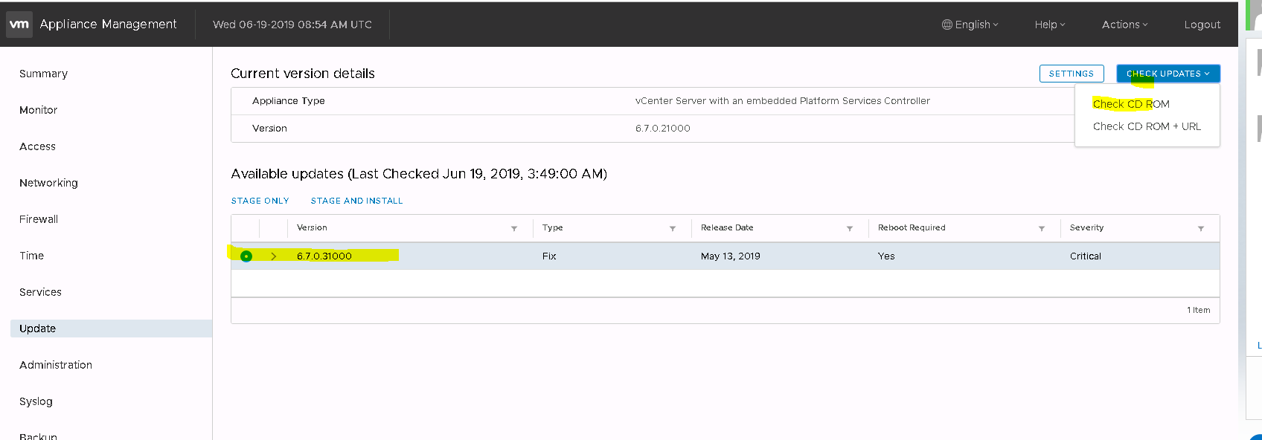

Review it and click on stage and install

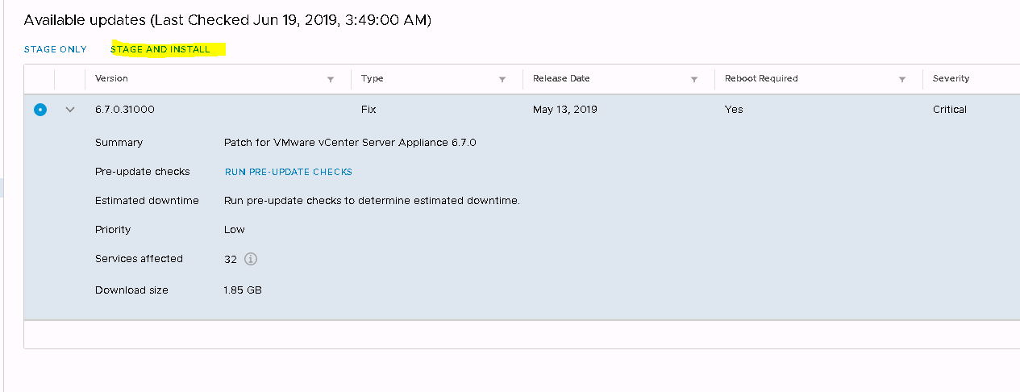

Accept license

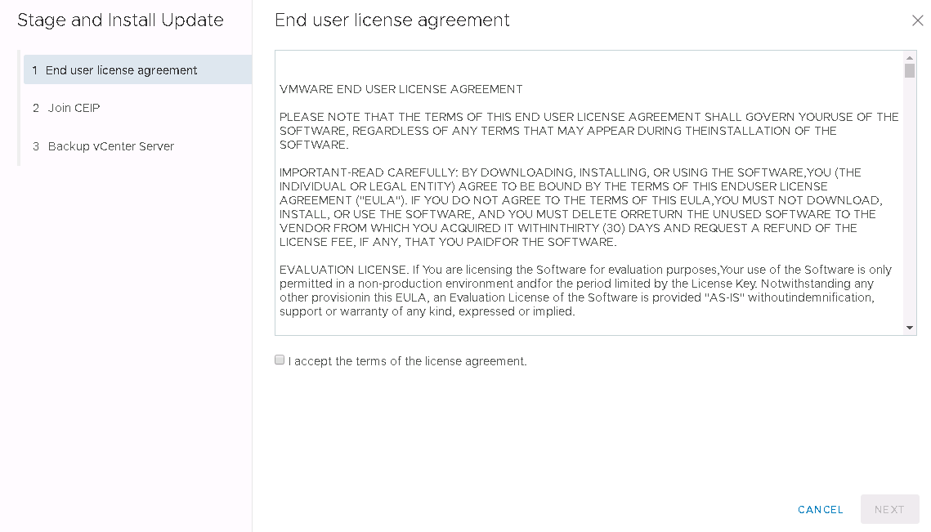

Uncheck Join CEIP

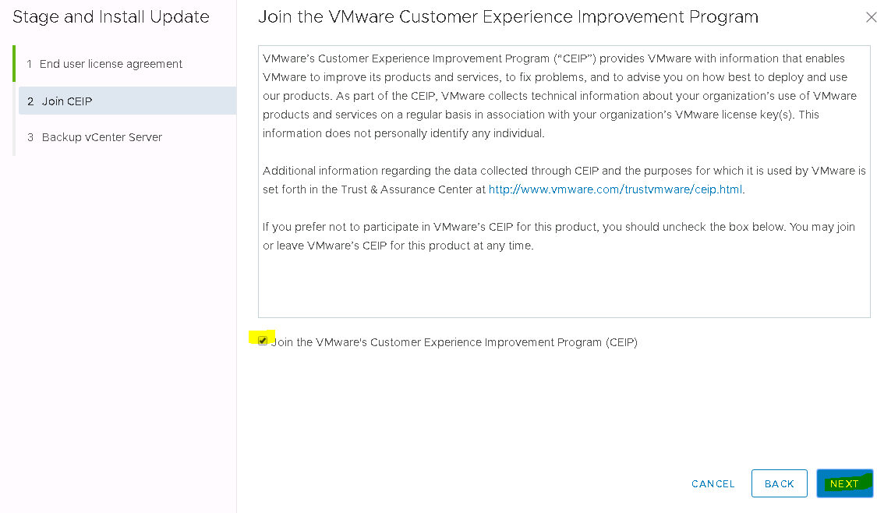

Click on I have backed up vcenter server

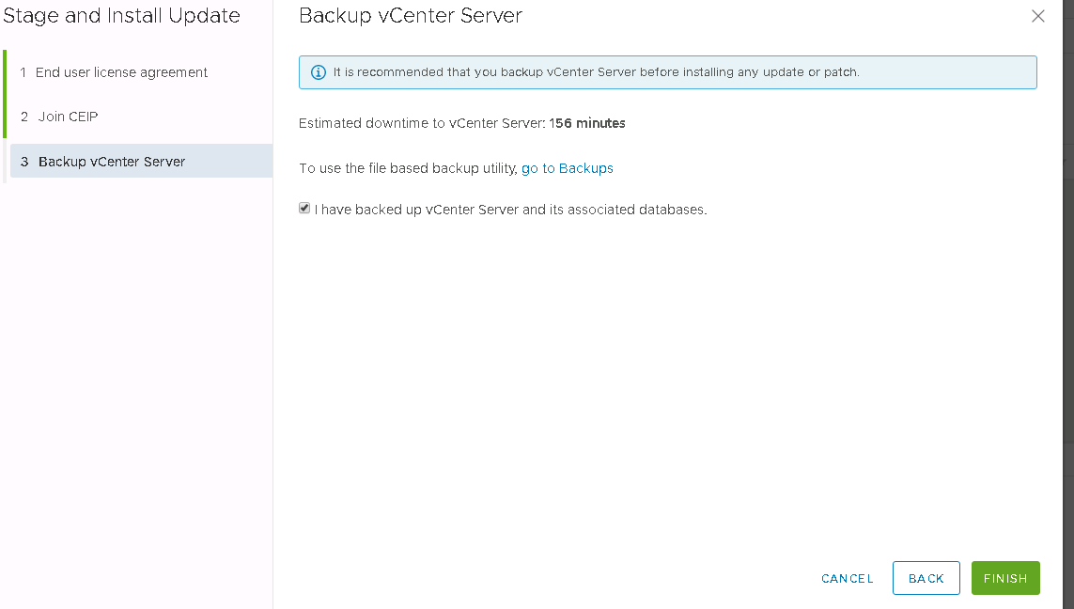

Click finish

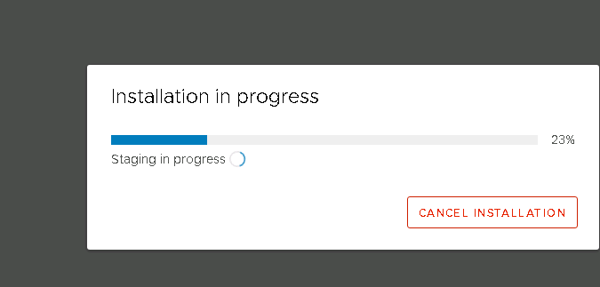

Your vcenter disconnect 1 or 2 times or multiple a few minutes

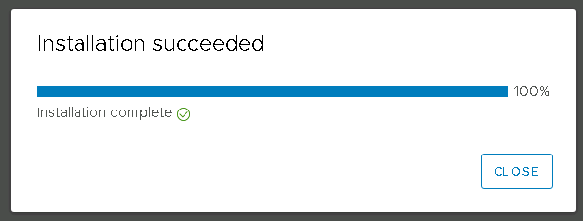

Click close and Again check for new upgraded version

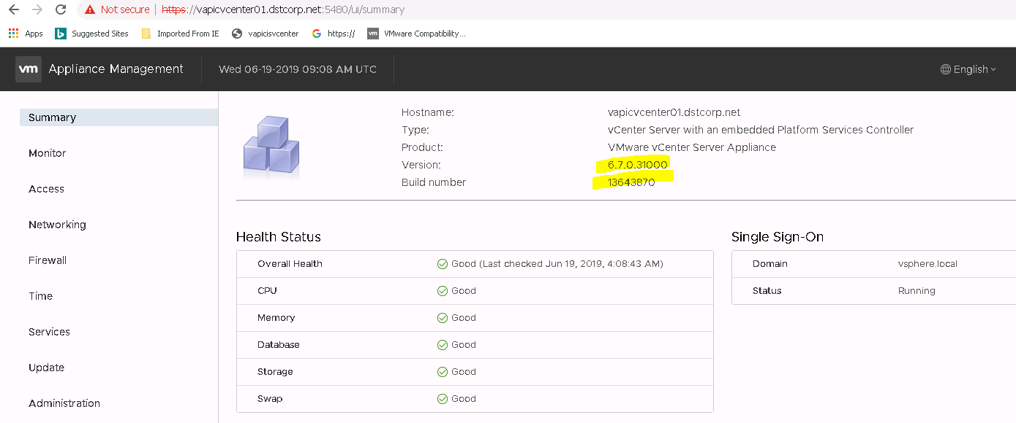

Now you can unmount/Disconnect ISO from VM